Mr.Jarst

if you do not have post-processing installed, then here is the instruction

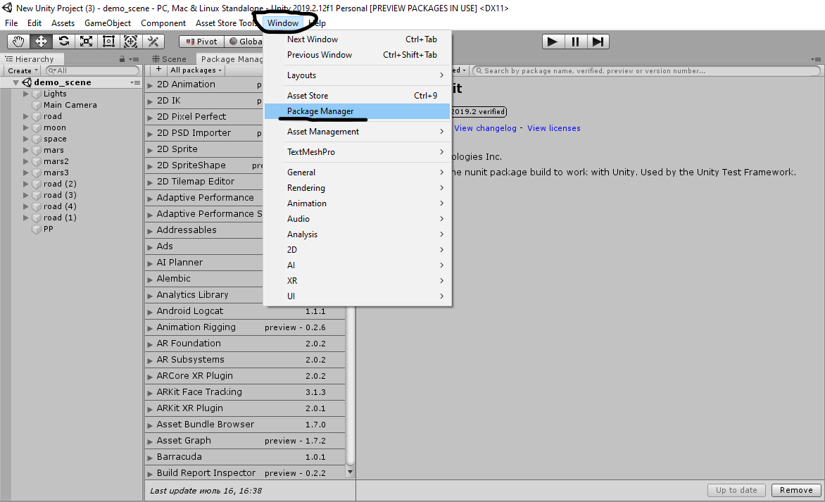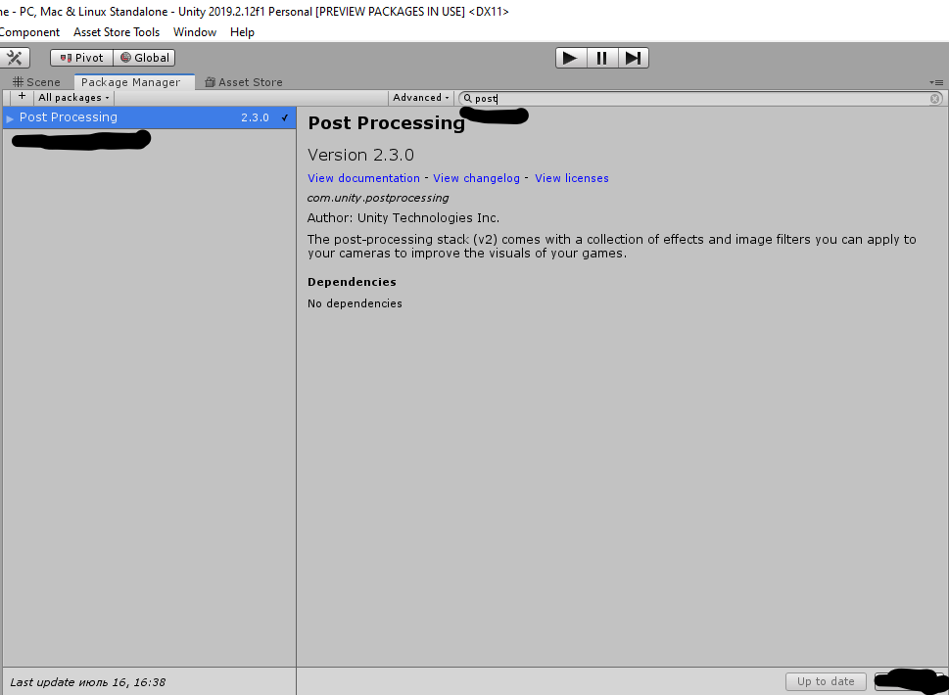

to achieve the look like in the screenshots, it is enough to set the following parameters:

PP- object in demo scene

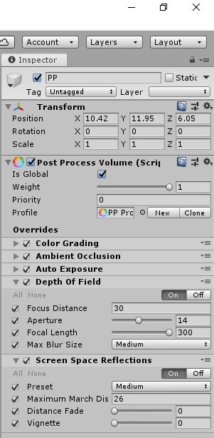

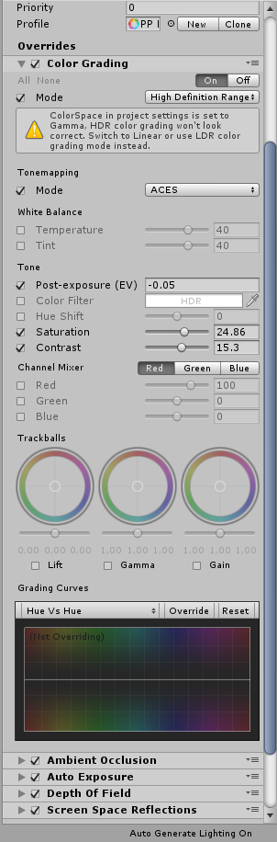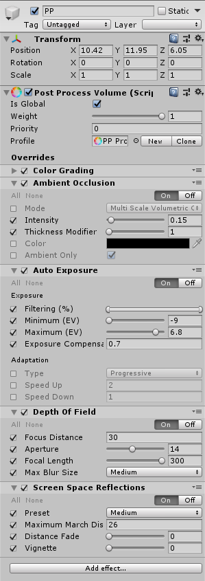

camera parameters

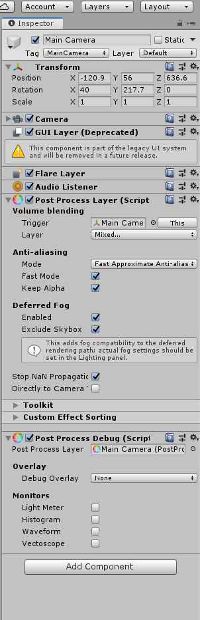

DIMENSIONS

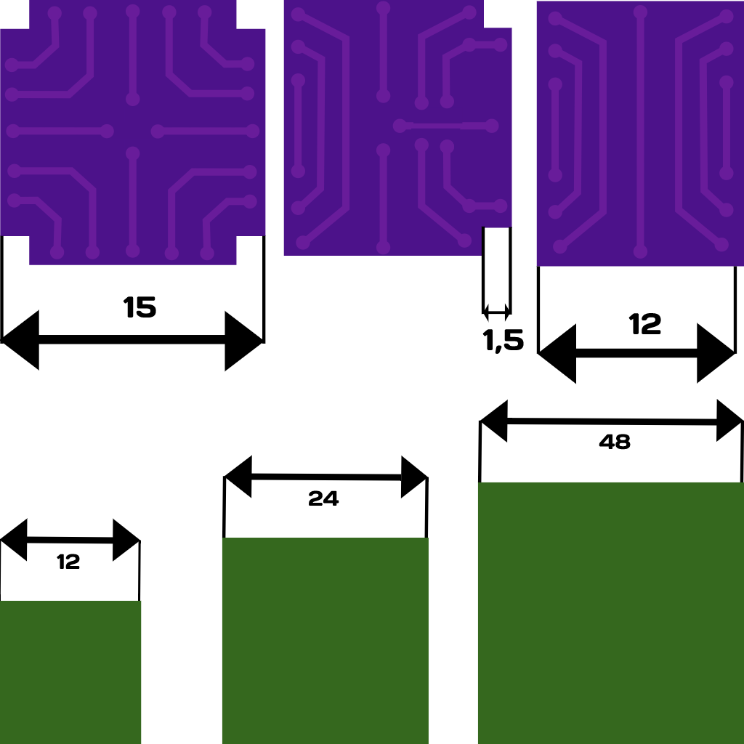

pleasant use